Statistics: Assignment No. 5

Preparation:
Read the following Minitab Blogs:

https://blog.minitab.com/blog/starting-out-with-statistical-software/correlation-what-it-shows-you-and-what-it-doesnt

https://blog.minitab.com/blog/understanding-statistics/no-matter-how-strong-correlation-still-doesnt-imply-causation

https://blog.minitab.com/blog/adventures-in-statistics-2/regression-analysis-tutorial-and-examples

Instructions:

Attempt all Four Exercises, Exercise 1 to 3 carry 2 marks each. Exercise 4 carries 4 marks.

This assignment is 10% of your final grade.

Body fat percentage data
A medical researcher studies obesity in adolescent girls. Because body fat percentage is difficult and expensive to measure directly, the researcher wants to determine whether the body mass index (BMI)—a measurement that is easy to take—is a good predictor of body fat percentage. The researcher collects BMI, body fat percentage, and other personal variables of 92 adolescent girls.
- Explore the relationship between the variables using Scatterplot and Correlation functions in Minitab.
- Briefly discuss your findings (< 100 words).

Aluminum properties data
An engineer at an aluminum castings plant assesses the relationship between the hydrogen content and the porosity of aluminum alloy castings. The engineer collects a random sample of 14 castings and measures the following properties of each casting: hydrogen content, porosity, and strength.
- Explore the relationship between the variables using Scatterplot and Correlation functions in Minitab.
- Briefly discuss your findings (< 100 words).

Wood Scientist

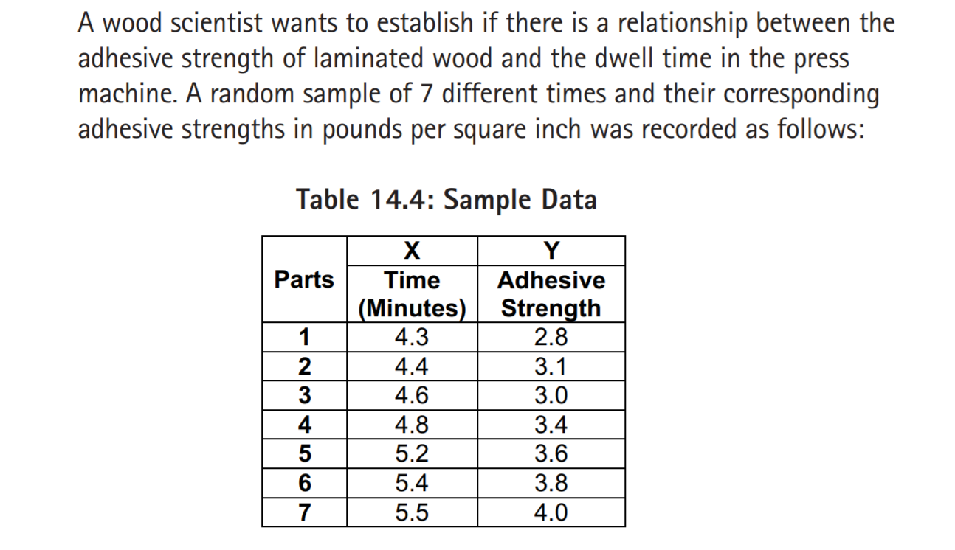
- Explore the relationship between the variables using Scatterplot and Correlation functions in Minitab.
- Briefly discuss your findings (< 100 words).

Car Sales
Reference SAQ 15.6.2 in the Module Units

Use the Minitab function Fitted Line Plot to solve the following:

